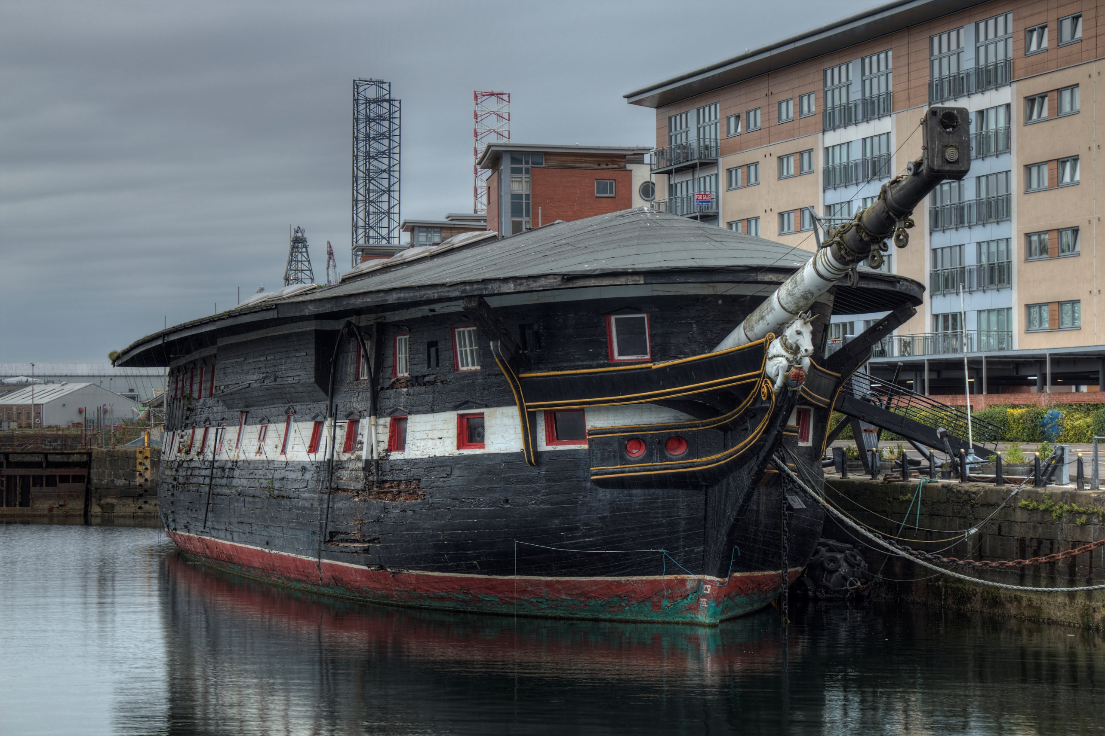

Appointment of Chief Executive

The Unicorn Preservation Society (HMS Unicorn South Victoria Dock Road, Dundee DD1 3PD)

September 2025
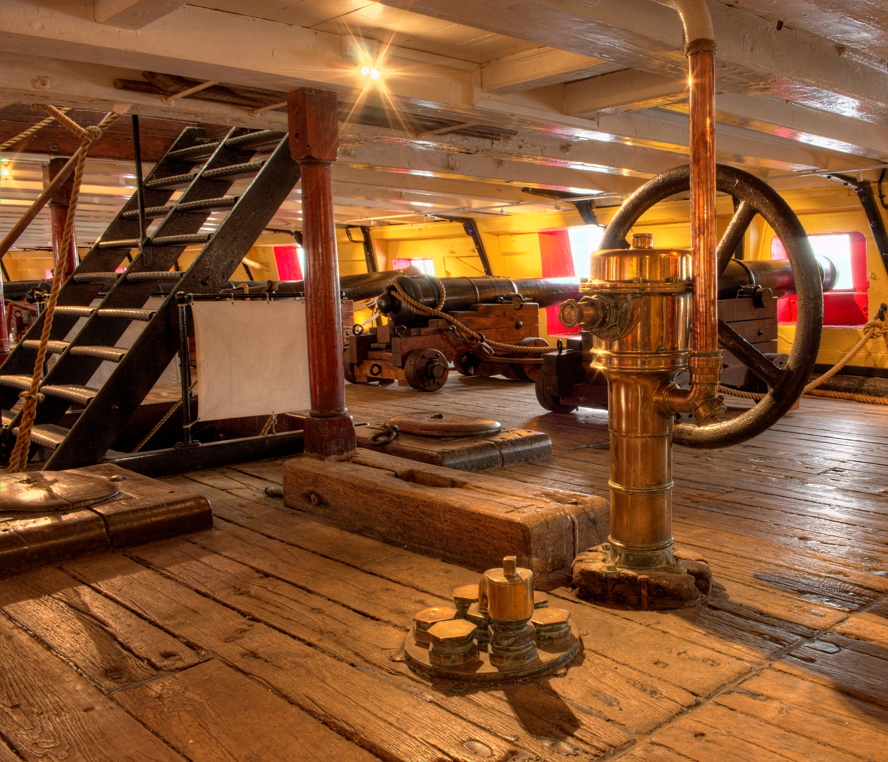

Contents

Contents 2

Welcome from the chair 3

About UPS 4

Mission, Mission, Values 5

Journey 6

Project Safe Haven 7

Our finances 8

Our strategic priorities 9

Job Description 10

Person Specification 11

Employment Terms 12

How to apply 12

Welcome



Dear Applicant,
Thank you for expressing your interest in The Unicorn Preservation Society (UPS). We have the great privilege of being responsible for the stewardship of a truly unique heritage asset; a Georgian warship – one of the oldest ships remaining afloat.
We have embarked on an extraordinary, ambitious journey which will see the HMS Unicorn delivered into a secure and sustainable future; it is an incredibly exciting time to join our charity.
We are looking for a Chief Executive who can provide both strategic and operational management by promoting a compelling vision of UPS’ strategy to stakeholders & partners and by providing effective leadership to UPS staff and maintaining strong relations with funders, external partners and beneficiaries.
Since its foundation more than 50 years ago, The Unicorn Preservation Society has grown and matured from a small charity having successfully saved HMS Unicorn from being towed into the estuary and used for gunnery practice, to a charity recognised for its work to secure this internationally important and critically endangered heritage asset.
Our mission is to deliver a world class museum experience, work continuously to safeguard the future of HMS Unicorn, and care for our collections while making them accessible to all. If you have the skills, experience and enthusiasm we are seeking, we look forward to hearing from you.

Christine Purdy
Interim Chair

About The Unicorn Preservation Society
HMS Unicorn is one of the few unreconstructed wooden warships in the UK and the only one present in Scotland. Launched in 1824, at a time when Britain was not engaged in any major wars, by the time the country needed a navy again she was redundant.
Unlike most other such ships, HMS Unicorn was not broken up but was towed to Dundee in 1873 to be used as a training ship, for what became the Royal Naval Reserve. She has remained in the city ever since. The heritage of the ship is, therefore, largely associated with Dundee and she is an integral part of the history of the town. She is also integral to Scottish naval history.
A vessel named 'Unicorn' was the flagship of the Scottish navy before 1544, when the then 'Unicorn' was captured during an English raid. This Unicorn became the first of 15 ships in the Royal Navy to bear this name.
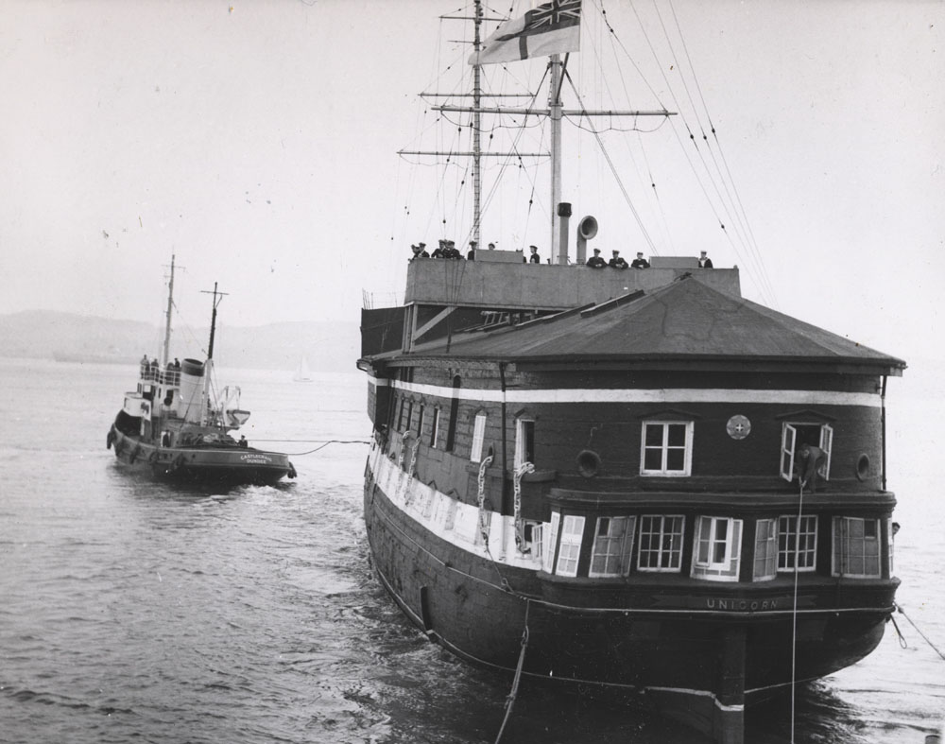
The Unicorn Preservation Society was formed in 1968 with backing from the Royal Navy with the specific intention of preserving the ship and her heritage as a visitor attraction. That responsibility has now passed to our generation, and we have ambitious plans to secure her future.
Since 1968, there have been a number of key steps in our journey:
- 1968-1970 – stabilisation of the ship;
- 1972 – Permanent docking;
- 1980 – Hull repairs;
- 1981 – Replacement of the Bowsprit;
- 2015 – Revised governance arrangements;
- 2018 – Conservation Management Plan completed;
- 2019 - Preliminary works commenced;
- 2023 – Production of architectural and engineering plans for Project Safe Haven, and successfully achieving Museum Accreditation;
- 2024 – Hull strengthening works to commence.

Our Mission
Our mission is to deliver a world class museum experience, work continuously to safeguard the future of HMS Unicorn, and care for our collections while making them accessible to all.

Our Vision
Our vision is to inspire those who visit and work with us, offering lifelong learning and engagement opportunities for our local communities and beyond. To do this we will:
- Inspire those who visit and who work with us;
- Care for and conserve the Unicorn and our collections and make them accessible to all;
- Work continuously to safeguard the future of the Unicorn.

Our Values
As an organisation, we are guided in our work by the following values:

Trust, Integrity, Impartiality
- We must be accountable for the organisation and the work we do in a principled, trustworthy, dependable and transparent manner;
- People understand that they can trust UPS in all areas of our work;
- We are trusted to spend funds appropriately;
- We remain impartial;
- We do not raise false expectations.

Caring, Empathetic, Supportive
- We are stewards of HMS Unicorn for future generations;
- Our actions will be in the best interests of the ship;
- Our decisions for the future will have empathy with the ship’s past life;
- We will remember compassionately those who have died in service;
- Those who serve as staff, volunteers and supporters will be respected no matter their background nor ability and will be encouraged to develop as individuals, learn new skills and to support others.

Passionate, Progressive, Collaborative
- We will work in partnership with those who share our passion for the ship and securing a safe and sustainable future for HMS Unicorn;
- We are progressive in our approach, regularly reviewing and improving our practices and working methods.

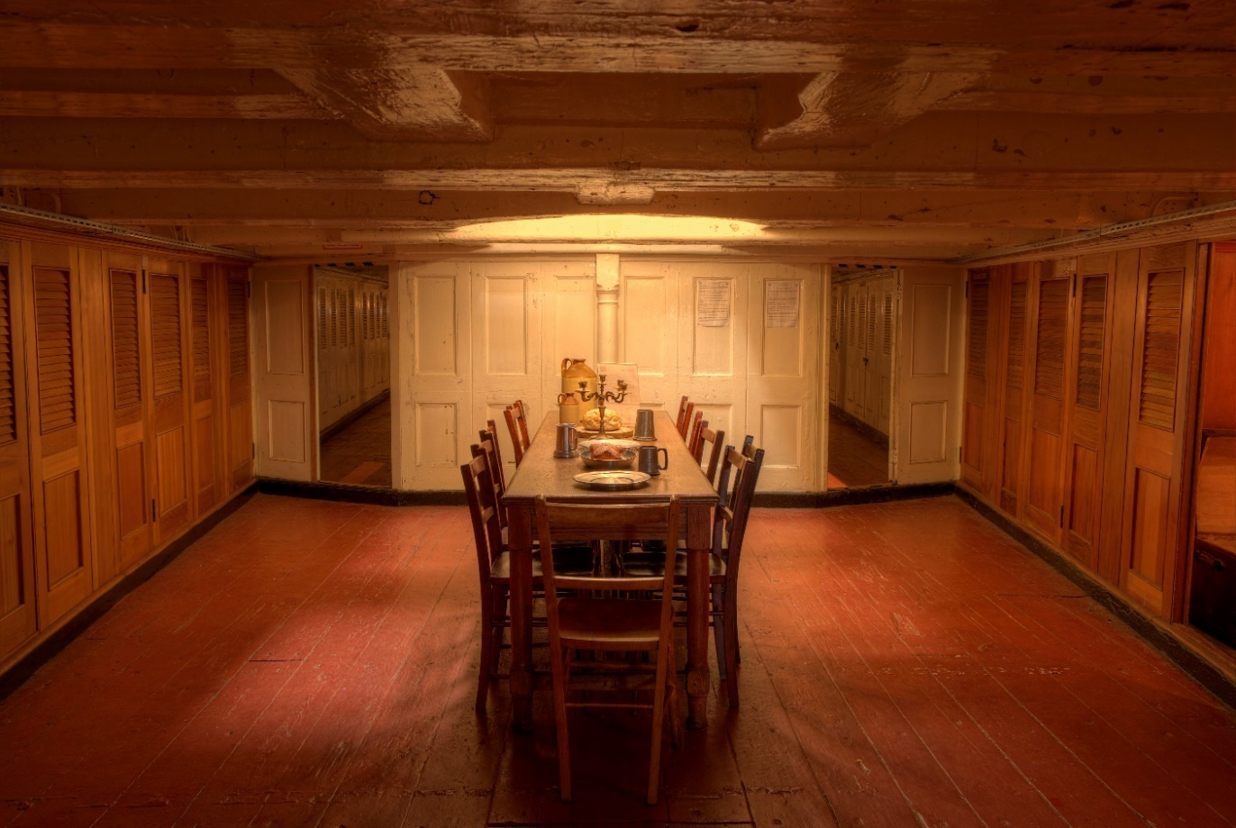

Where we have reached in our journey
The Society has achieved a step change in the past five-years. We have developed in our impact, capability to deliver and our income. We believe we have made a transformational change in progress towards securing a sustainable future for HMS Unicorn.
- In the past 5-years we have raised more than £1,000,000 of funding to undertake preparatory works in readiness for Project Safe Haven, the migration of the ship to the East Graving Dock.
- Laser and sonar surveys have been undertaken which, when combined with internal and external shipwright surveys, are being used to develop a structural model giving us an accurate picture of the condition of the ship for the first time.
- We have achieved Museum Accreditation with Museums Galleries Scotland.
- We have materially improved our technology implementation with our structured network, PC deployments, EPOS system and integrated accounting systems, website and online services.
- Our retail offering in the Museum shop has been transformed through investment in better stock lines, stock management and improved branding.
- Visitor numbers are recovering slowly following the COVID-19 pandemic, but pre-pandemic visitor numbers had been developed to their highest level in the ship’s current location.
- During 2023 architects and marine engineers were engaged to deliver a vision of the completed project and cost plans, which together with the earlier surveys and scans form the basis of applications for major funding.
- The award of more than £1m of major funding is allowing significant hull strengthening work to be undertaken as a precursor to the ship being moved into her new home as a part of Project Safe Haven.
- Submitted NLHF bid and plans for £10m project to move HMS Unicorn into the East Graving Dock in City Quay, Dundee.

Project Safe Haven
The project will see HMS Unicorn moved into a restored East Graving Dock in Victoria Quay in Dundee and new customer-facing and exhibition space developed.
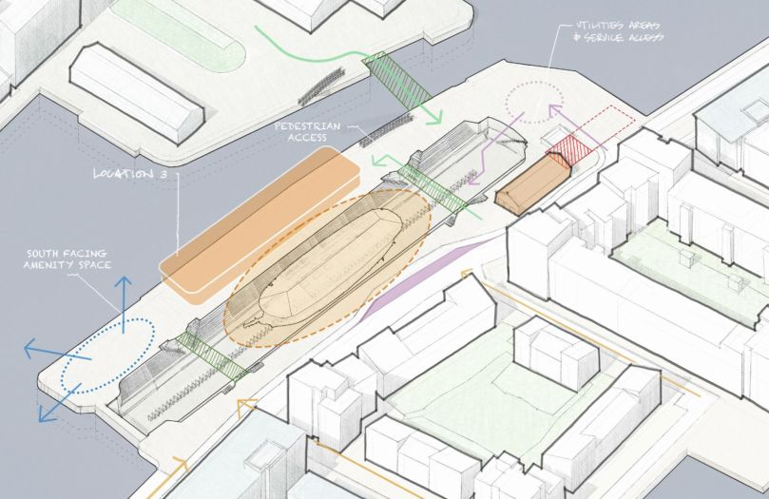
This is an ambitious and transformational £30m project set to be delivered over the next 8 to 10 years placing HMS Unicorn at the heart of a reimagined and revitalised Riverside in Dundee.
We aim to deliver a high-quality visitor experience supported by a diverse range of programmes and events, capitalizing on the site's unique location. These programmes will address a broad range of subjects such as management of a unique heritage venue, skills development, community and volunteer engagement, learning and education, and volunteering.
The next steps to be undertaken require the refinement of the plans, engineering and budgets through a Development Phase to establish a project that is deliverable and meets the expectations of all stakeholders.

Our finances
Financial returns for the charity can be found on the OSCR website by searching for charity SC002771 here:
https://www.oscr.org.uk/about-charities/search-the-register/charity-details?number=2771
A significant proportion of our income is from charitable trusts and foundations. Much of this funding is to support the museum activities of the charity and the conservation of the ship.
A snapshot of our finances across the past 20 years are summarised below:
£’000 | 2001 | 2006 | 2011 | 2017 | 2018 | 2019 | 2020 | 2021 | 2022 | 2023*
Income - Operations | 28.6 | 28.9 | 34.3 | 61.8 | 57.1 | 71.7 | 31.1 | 43.8 | 57.0 | 66.0
Income - Fundraising | 38.4 | 29.3 | 43.1 | 88.9 | 307.4 | 202.9 | 272.9 | 305.5 | 363.9 | 345.7
Expenditure | (42.6) | (62.8) | (111.7) | (166.8) | (169.2) | (260.7) | (247.9) | (304.9) | (456.4) | (432.0)
Surplus | 24.5 | (4.2) | (34.3) | (16.1) | 195.3 | 13.9 | 57.1 | 44.4 | (35.5) | (20.3)
Cash | 23.4 | 25.7 | 42.1 | 60.2 | 69.5 | 97.8 | 220.9 | 226.6 | 514.4
Net assets | 179.1 | 195.7 | 197.9 | 239.2 | 434.4 | 448.2 | 505.5 | 527.6 | 410.2
* Draft, 2023 financial statements are in the course of preparation.

Our strategic priorities
As agreed in 2022

UPS as an organisation
- We will achieve Museum Accreditation status and ensure this is maintained;
- We will ensure there is a fit-for-purpose staff structure, and that staff are suitably trained to deliver our objectives;
- We will continue to develop a positive external profile for the Unicorn by using a range of marketing methods;
- We will continue to safeguard the ship, and plan towards a move into dry dock for long term preservation;

Our Collections
- We will continue to develop an ambitious exhibitions programme, tailored to a range of audiences with clear learning outcomes and fully evaluated;
- We will create a prioritised programme of conservation work for our collections;
- We will continue to locate and document all UPS collections, and ensure our collections are cared for in line with nationally recognised Museum standards;
- We will develop our digital offer and create a digital strategy which includes providing access to our collections and improving collections care;

Our Visitors
- We will explore opportunities to reach new audiences, both through interpretation on board and through outreach opportunities;
- We will seek to learn more about our audiences, to enable us to tailor what we offer;
- We will become a key part of the tourism and heritage ‘offer’ in the waterside area of Dundee;
- We will ensure all staff, volunteers and Board members are trained and are confident to act as Ambassadors for Unicorn both on board and off;
- We will develop our valuable volunteer cohort to ensure their skills are utilised and they feel enabled to contribute effectively to the running of the ship;

Finance
- We will increase our financial sustainability through internally generated income;
- We will create a strategy for both retail and income-generating events that matches the high quality ‘brand’ that we are seeking to develop for the Unicorn;
- We will continue to investigate and apply for external grant funding opportunities and ensure a strategic approach to external fundraising is created;

The ship and facilities
- We will instigate a comprehensive maintenance programme covering both the ship and the immediate dock-side area;
- We will continue to implement a planned programme of repairs to the ship;
- We will investigate and develop plans for interior improvements that will allow greater utilisation of the space for a range of actual and potential audiences;

Partnerships
- We will continue to develop mutually beneficial relationships with local attractions and community groups;
- We will nurture new high-level strategic relationships that have developed recently, and explore options for extending these;
- We will become a centre of excellence allowing us to contribute to the tourism and heritage sector in Scotland.

Job Description
The Chief Executive Officer (CEO) is the most senior executive officer of the Unicorn Preservation Society (UPS) and is responsible to the Board of trustees. The CEO is responsible for the implementation of the Strategic Plan approved by the trustees. The role will be line managed by the Chair of trustees.

The CEO of UPS must provide both strategic and operational management by promoting a compelling vision of UPS’ strategy to stakeholders & partners and by providing effective leadership to UPS staff and maintaining strong relations with funders, external partners and beneficiaries.

Main duties and responsibilities
1 | Leadership  - Support the trustees in the development of strategic plans, be responsible for implementation of those plans and for the day-to-day operational leadership of the charity;  - Oversee the conservation and preservation programme for HMS Unicorn (known as Project Safe Haven) and to promote innovation in heritage preservation and public engagement;  - Develop strategic partnerships with heritage sector, academic and other external organisations to support delivery of our charitable objectives and Project Safe Haven.
2 | Performance  - In collaboration with the project team deliver Project Safe Haven on time, on budget and within planned resource pools  - Achieve planned levels of funding required through programme of major public grant, trusts and foundations, community fundraising and High Net Worth Individuals;  - Develop, engage and maintain key stakeholder pool, influencers and relevant academic and historic bodies to ensure Project Safe Haven success  - Promote engagement with communities.
3 | People  - Foster a culture of collaboration, innovation, and accountability;  - Develop and maintain a high-performance management team.
4 | Governance  - Work with the Company Secretary to ensure:  - Effective governance and internal control frameworks;  - Statutory, regulatory and financial compliance;  - Effective risk management, including insurance;  - Implementation of Board decisions.  - Support the Board in delivering their governance responsibilities;  - Ensure effective framework of policies and procedures are in place.

Person specification
Attributes | Essential | Desirable
Qualification | - Proven senior leadership experience
Skills and experience | - Strong attention to detail and organisational capability;  - Experience of working with public sector funders to deliver major programmes;  - Developing and managing new teams with little or no experience of working together  - Ability to engage with a diverse range of stakeholders across a wide range of backgrounds and interests;  - Strong understanding of corporate finance and performance management principles;  - High level of business acumen. | - Good understanding of the principles of heritage conservation;  - Track record of delivering major projects in heritage;  - Familiarity with diverse business functions such as marketing, PR, finance etc.

Attributes | Commitment | Focus
Personal competencies  Individuals should be able to | - empathise with the vision, mission and aims of the organisation; | - think creatively  - keep mission-focused and able to see the bigger picture  - demonstrate a willingness to listen and learn  - decisive in high pressure situations
 | Communication & team work | Accountability
 | - able to inspire others and communicate clearly and sensitively and promote collaborative working; | - exercise sound and independent judgement  - manage difficult and/or challenging situations

EMPLOYMENT TERMS & CONDITIONS

Place of work: HMS Unicorn, South Victoria Dock Road, Dundee DD1 3BP

Hours of work: The responsibilities outlined can be managed within a 5-day working week with 2/3 days per week based in Dundee. There is a requirement to work one weekend in five (as do other members of the management team) late on some occasions, particularly when attending 3rd party events in the City, or when delivering the main Company events. The ship is closed on a Monday.

Remuneration: £65,000 p.a.

Benefits: A pension scheme is available plus other benefits to be discussed on appointment.

Holiday: 34 days including all Bank Holidays.
Probation Period: There will be a probation period of three months. During this time either party may give one month’s notice. After the satisfactory completion of the three months the position will become permanent. Thereafter the notice period will be three months.
Full details and terms and conditions of employment will be issued when an offer of employment is made.

HOW TO APPLY

Please download further details of the position from our website:
www.maryleboneexecutivesearch.com/jobs
For an informal confidential discussion call Richard Evans on 07958 984161 or 020 3126 4858 or Sean Bonnington on 07796 546555
Apply online with a full Curriculum Vitae detailing your skills and experience together with a 2 page Covering Letter clearly outlining your motivation to undertake the role and how you meet the competencies required for the position as stated in the Person Specification.

Closing date for applications: 15 October 2025
Long List interviews: 16 – 23 October 2025
Final Panel Interviews: 30 October 2025
Start Date: 1 February 2026
To find out more visit: www.hmsunicorn.org.uk

