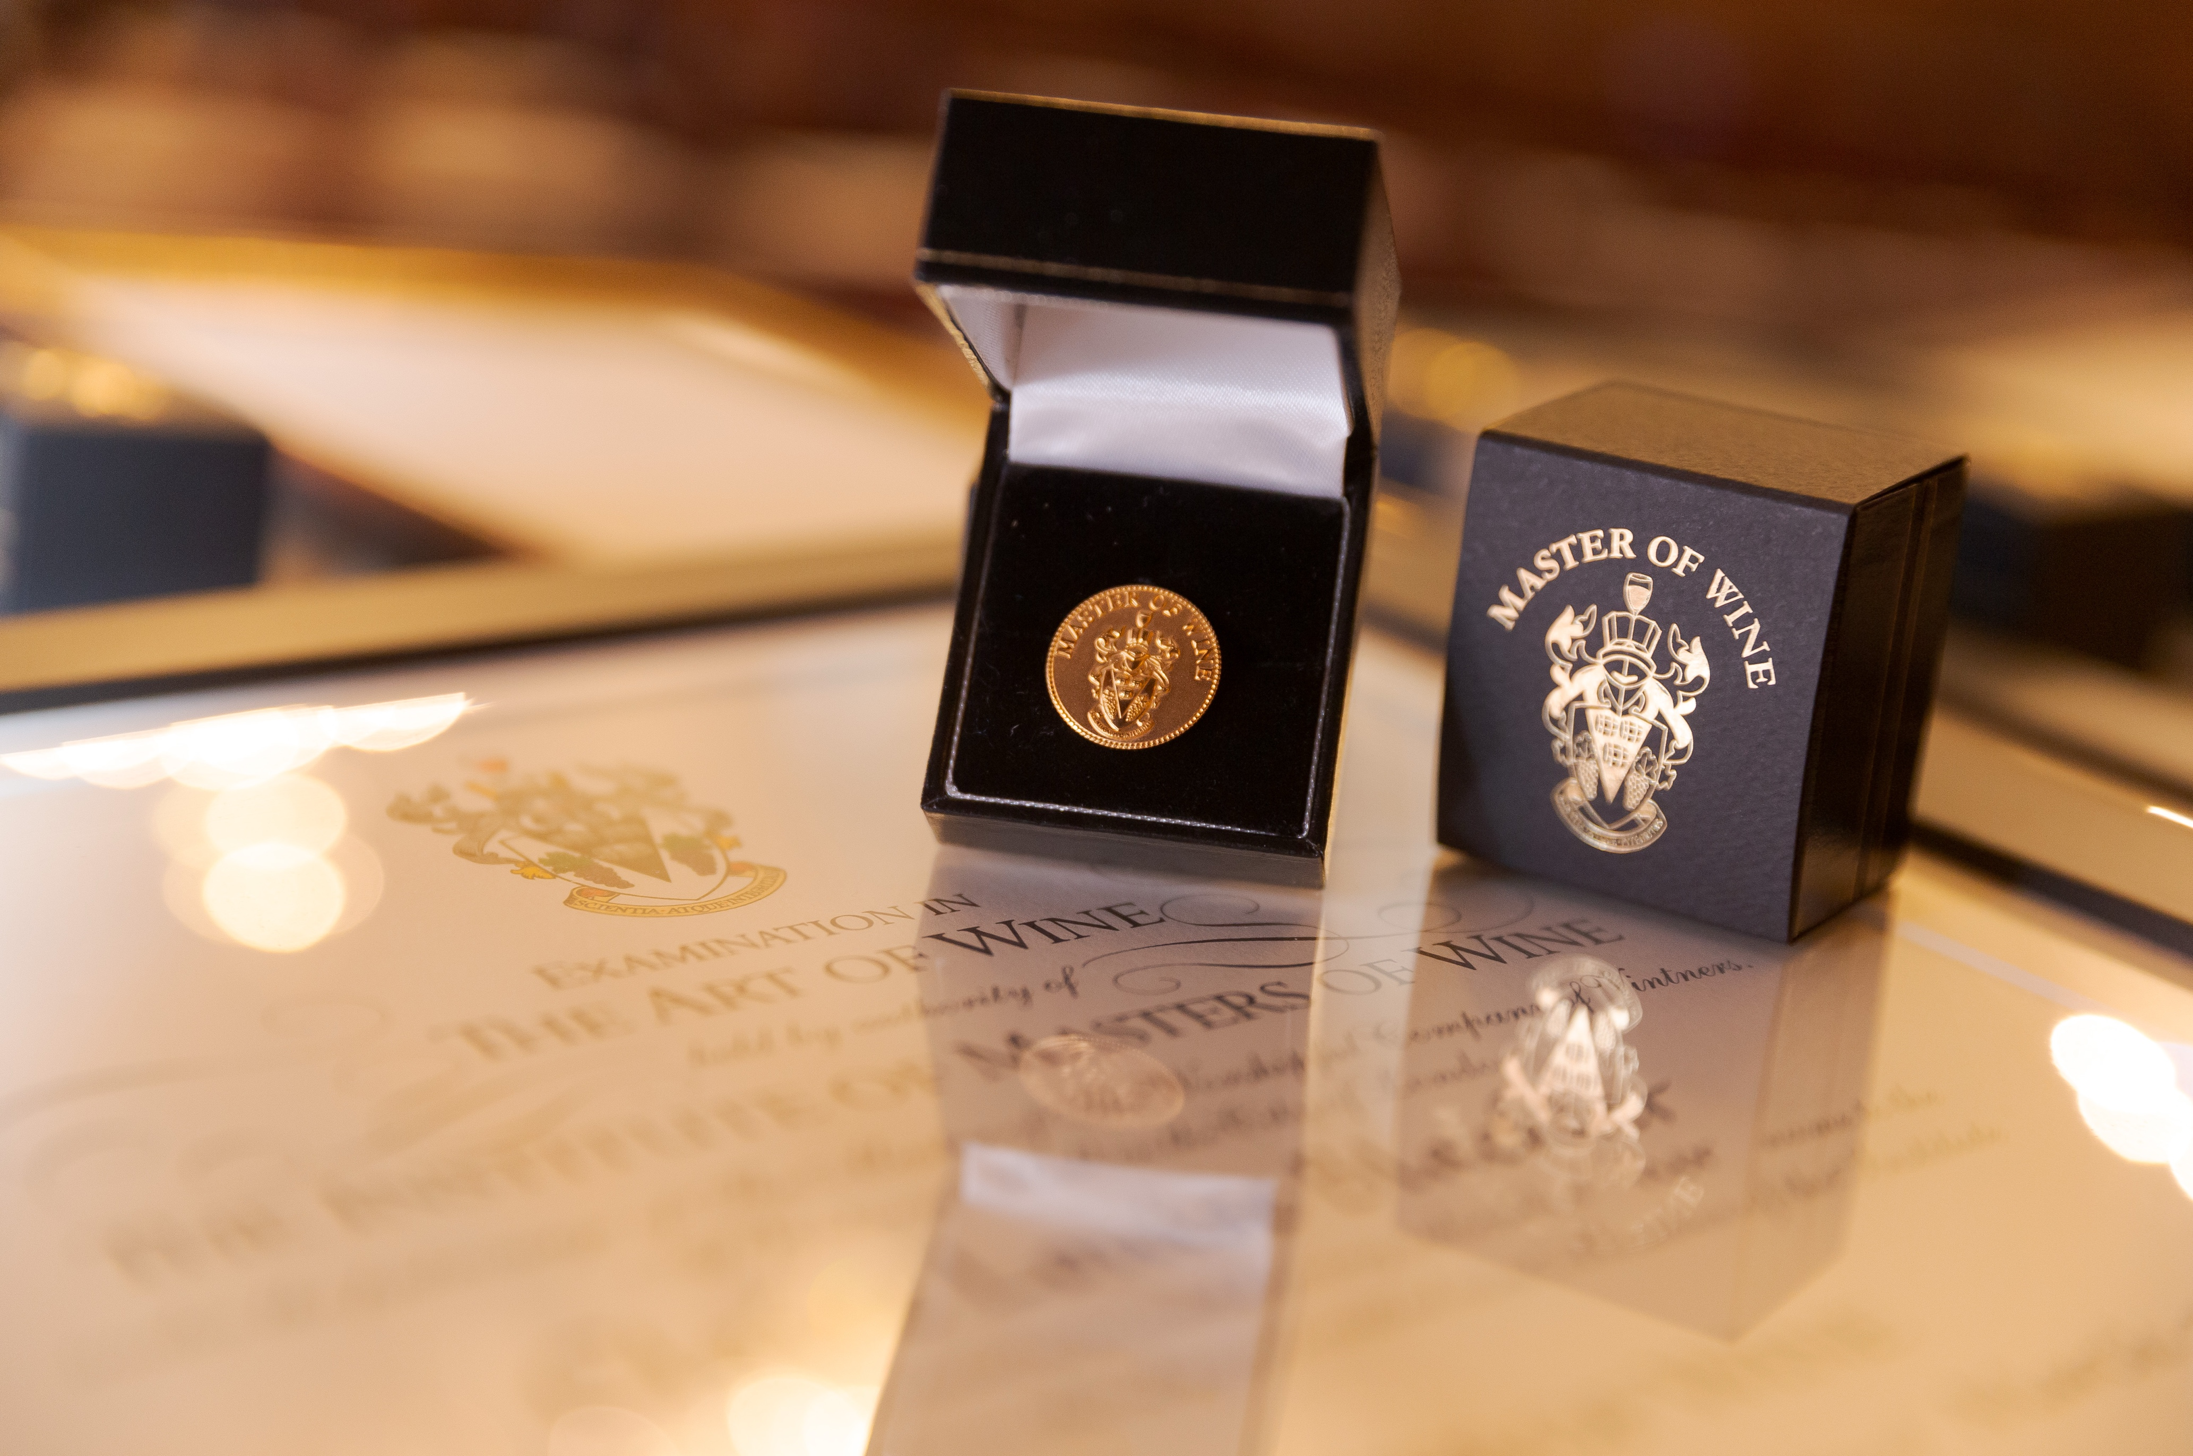

EXECUTIVE DIRECTOR
Candidate pack

September 2025

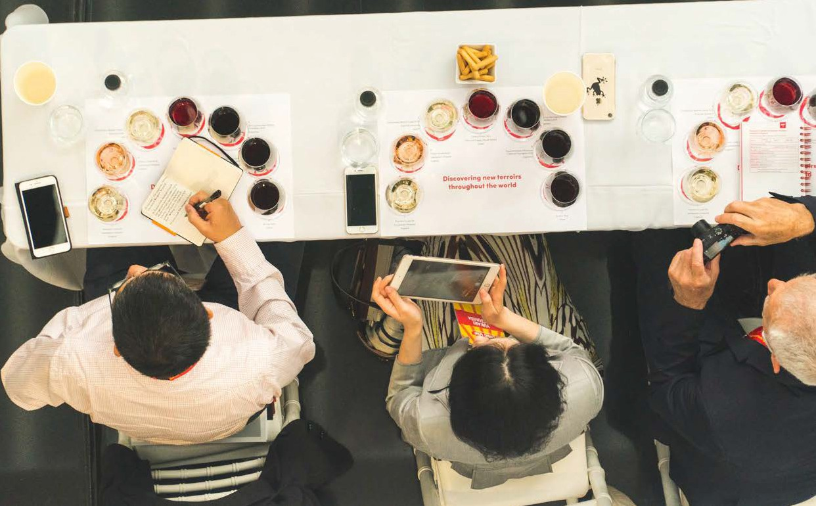

INTRODUCTION

The Institute of Masters of Wine (IMW) is a global membership organisation (whose members are the Masters of Wine) established in 1955 to promote the highest standards of professionalism within the wine trade and allied industries and sectors. It is funded through member and student fees and a global network of industry supporters who share the IMW’s values of excellence, interaction and learning.

The IMW is at an exciting chapter. The past 10 years have been transformative for the IMW, seeing the membership continue to grow internationally and the interest in the study programme as popular as ever. The focus over the coming five years will be implementation of Strategy 2030 which seeks to strengthen finances, its reputation and its positive impact globally.

As the global wine trade continues to evolve, becoming increasingly complex, the need for a pinnacle body that develops the leaders in its field, with a true mastery of all aspects of the subject, is as crucial as at any time in the IMW’s 70-year history.

ABOUT US

Our mission
The IMW’s mission is to foster excellence, interaction and learning across all sectors of the global wine community.

Our vision
A thriving global wine industry within which the IMW and its members are recognised for leadership and as highly valued contributors.

The definition of a Master of Wine
A Master of Wine is someone who has demonstrated, by way of rigorous examination, a thorough understanding of all aspects of wine and an ability to communicate clearly. A Master of Wine will actively encourage others in the pursuit of knowledge and will seek to bring wine communities together.

The IMW key values
Members of the IMW, examination candidates on the study programme and the IMW team will:
- Act at all times with integrity, judgement, independence and informed courage of conviction.
- Be dedicated to the pursuit of excellence in all their professional activities.
- Seek to communicate effectively with all stakeholders.
- Be dedicated to opening the opportunity of the IMW to others.
- Act with respect to each other, and to those with whom they come into contact in their role as Masters of Wine, examination candidates on the study programme, or as employees of the IMW.
- Be committed to and exercise responsibility for their own professional development.
A global family of MWs
MWs prove their understanding of all aspects of wine by passing the MW exam, recognised globally for its rigour and exacting standards. The MW exam involves a series of theory papers and blind tasting exams, plus an individual research paper on a subject that will contribute to the understanding of the world of wine.

After passing the exam, MWs are required to sign a code of conduct before they are entitled to use the initials MW. The code of conduct requires MWs to uphold the highest standards of commercial conduct within the industry. Since the first exam in 1953, 517 people have become an MW, and the IMW actively seeks new candidates around the world.

MW study programme
To become a Master of Wine, it is necessary to complete the IMW’s study programme. The study programme comprises the stage one assessment (S1A) and three parts of the MW exam itself. Masters of Wine volunteer their time to help the MWs of the future realise their dream. They offer advice and guidance through a series of educational seminars, course days and assignments to assist examination candidates in their preparations.

Examination candidates can expect to learn from many other Masters of Wine as well as leading figures in the wine industry throughout their study journey. Not everyone who takes the exam goes on to become an MW. Even so, all those who join the programme experience the benefits of increased knowledge and extensive contacts. The IMW considers former examination candidates to be part of its extended family.

As membership numbers increase, there is an exciting opportunity to continue satisfying the needs of the older membership while meeting the demands of a new breed of vibrant and increasingly international MWs who wish to leverage their status to the benefit of all.

This year (2025), the IMW has welcomed five new MWs to the membership.
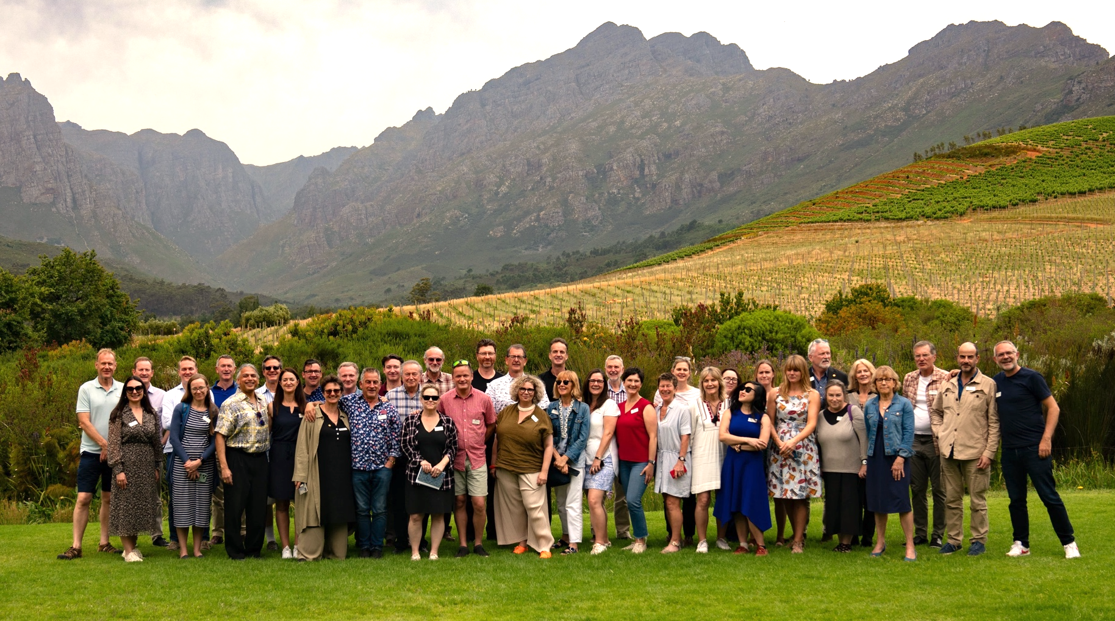

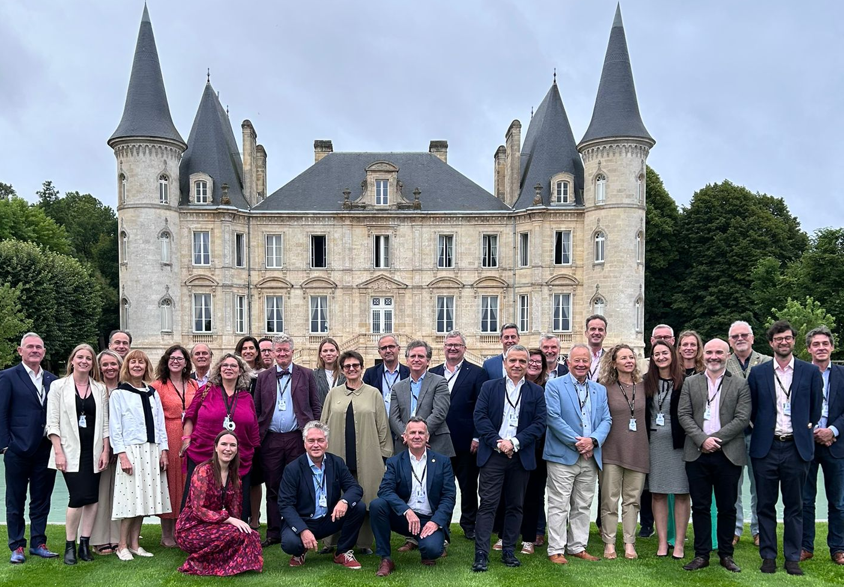

IMW SUPPORTERS

The IMW’s supporter network contributes views, ideas, venues and wines. Ranging from one of the world’s oldest Champagne producers to a world class glass manufacturer, they reflect the reach and diversity of the industry. Whatever their expertise, each supporter shares the IMW mission to lead the global wine community towards a sustainable and inclusive future through the highest standards of expertise and integrity.

Principal supporters

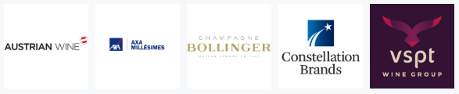

Major supporters

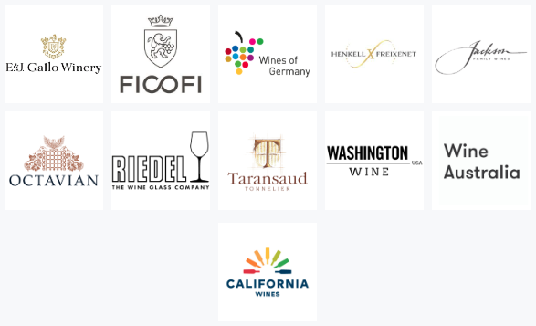

Supporters

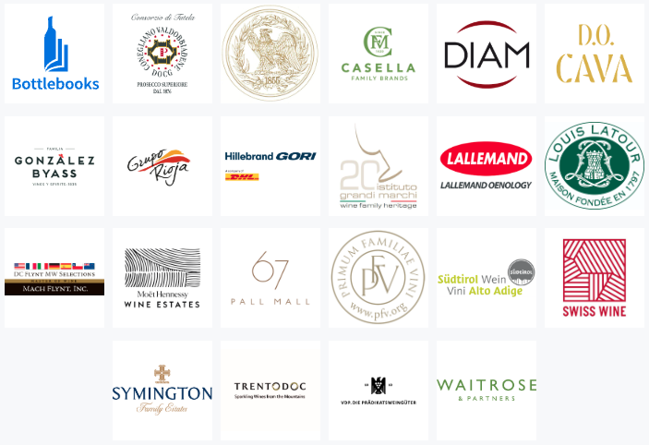

FACTS AND FIGURES
MWs and exam candidates from the 2025-2026 Annual Review
104
MENTORS
27
RP ADVISORS
36
STAGE THREE
STUDENTS
205
STAGE TWO
STUDENTS
105
STAGE ONE
STUDENTS
346
STUDENTS
From 43 countries
(2024-2025 MW study programme)
FROM
29
COUNTRIES
418
MASTERS OF WINE
Male 267 | Female 151

THE ROLE

Post title: | Executive director
Salary: | £105,000 p.a. plus benefits
Reports to: | Chair and honorary officers of the IMW’s council  (elected board of directors)
Location: | Riverlight Quay, London, SW11
Direct reports: | Institute of Masters of Wine executive team

OVERALL OBJECTIVE OF THE POST

The executive director is responsible for all the operations of the IMW and supports council and its committees in their development of its longer-term strategy and governing policies, ensuring that all the IMW’s external stakeholders understand and support the IMW’s purpose and direction, and continue to see the IMW as the authority and lead convener on the key issues in the global wine trade.

The job may include a significant amount of international travel. There are exciting trips planned to significant wine producing areas globally in the coming year, as well as the annual education seminars in Australia, USA and Europe.

The executive director leads the organisation, managing, developing and motivating a team based largely in London but also internationally. The culture of the IMW is one of collaboration between the multiple professionals it employs and the departments they work in to deliver the IMW’s services.

A strong emphasis on stakeholder management is key to the role, and the executive director will develop strong and positive relationships not only with the IMW’s employees but with members, examination candidates, supporters (a crucial task will be to focus on supporter retention and/or generation) and other key stakeholders.

A desire to continue growing the IMW’s increased global profile, influence of the IMW worldwide and the MW qualification in different geographies means that the executive director will need to actively drive the IMW’s global footprint to ensure it achieves greater recognition of the profession in the major and emerging economies of the world.

Within this, driving change and diversity while embracing digital transformation and ensuring sustainability, accountability and continued business growth are critical to the role.

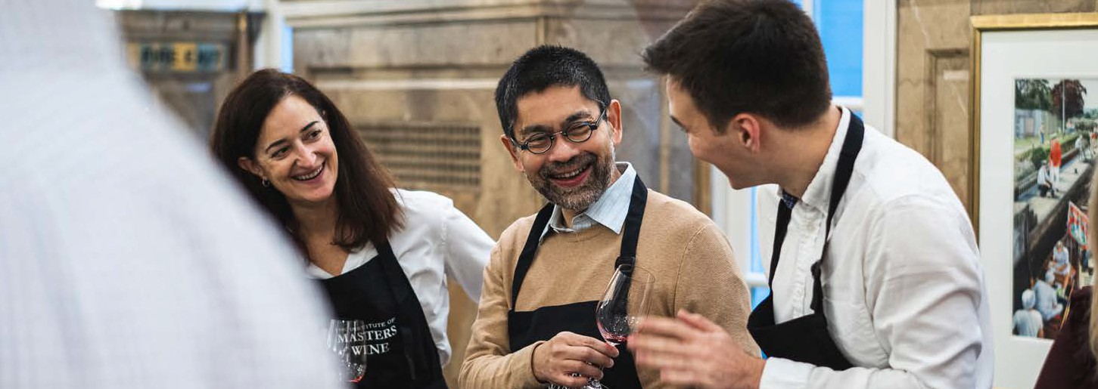

PERSON SPECIFICATION

The executive director must possess a broad range of skills, including the precision associated with managing a team to deliver a global study programme within a defined budget, while having a strong yet sensitive personality to engage the many internal and external stakeholders, from members and executive team, to examination candidates, supporters and all sectors of a global wine trade.

The executive director must be an experienced professional who can demonstrate a successful track record of leadership, collaboration and reputation management with these skills and experience:
- Strong interpersonal skills with high emotional intelligence, and strong yet sensitive personality to engage with the many internal and external stakeholders from members and examination candidates to supporters and all sectors of a global wine trade.
- Experience of working with people from different cultures and geographies, as well as identities.
- Motivational management style and the ability to work in an international context.
- Experience of developing strategies and management practices to achieve organisational objectives.
- Excellent communication and presentation skills.
- Consultative, consensus-building approach and abilities.
- Methodical organisation skills.
- A high level of initiative and drive.
- Consumer-centric.
- Financially astute.
- Must have the right to live and work in the United Kingdom.

Finally, the IMW hopes its new executive director would have an interest in wine. Although the role does not require experience in, or knowledge of, wine, it will involve access to—and working closely with—the world’s leading wines, producers and experts, and a desire and enthusiasm to maximise this opportunity would be an asset.

It is also important to note that the IMW executive team is a small, professional and hard-working one. The executive director does not have a personal assistant and is required to make their own travel arrangements, organise their own diary, sit on most of the committees and take notes/minutes etc. Indeed, the ‘make-your-own-tea and help move boxes’ philosophy is one that all subscribe to and accept as part and parcel of contributing to the seamless delivery of the IMW’s business.
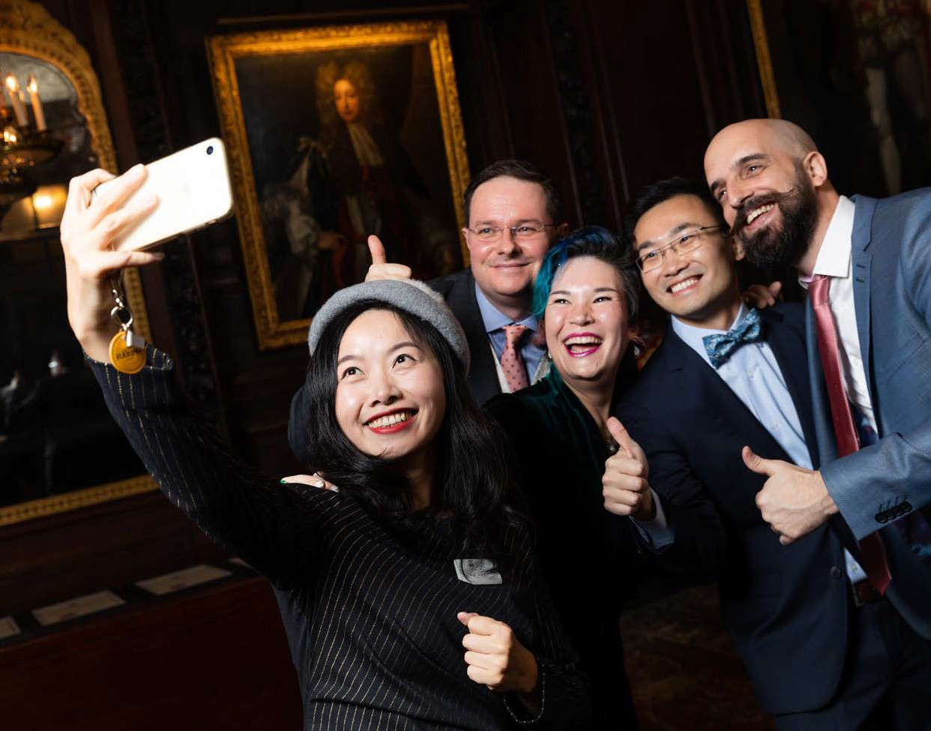

HOW TO APPLY

The closing date for applications, which should be in the form of a CV and cover letter, is 5 October 2025.

Please visit www.maryleboneexecutivesearch.com/jobs to apply. For an informal confidential discussion call Richard Evans
07958 984161 or 020 3126 4858.



