
Appointment of the Chief Executive/Clerk
The Worshipful Company of Gardeners

Advising Consultant: Richard Evans, Director, Marylebone Executive Search
T: +44 (0)20 3126 4858 M: +44 (0)7958 984161
1 King William Street, London EC4N 7AF
E: info@maryleboneexecutivesearch.com Website: www.maryleboneexecutivesearch.com



Table of Contents

WELCOME FROM THE MASTER………………………………………………………………………..P3
ABOUT THE GARDENERS’ COMPANY………………………………………………………………..P4
JOB DESCRIPTION…………………………………………………………………………………………….P5
PERSON SPECIFICATION…………………………………………………………………………………..P7
EMPLOYMENT TERMS & CONDITIONS……………………………………………………………. P8

HOW TO APPLY………………………………………………………………………………………………. P8

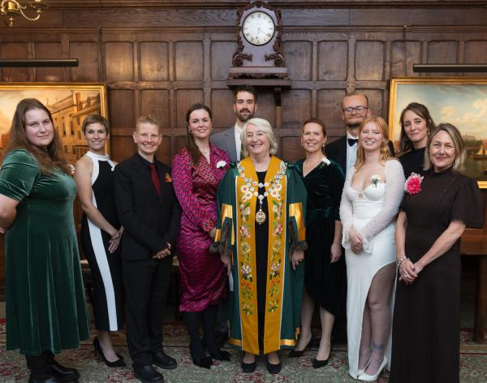
The Gardeners’ Company Recent Student Awards Ceremony

WELCOME FROM THE MASTER

Dear Applicant
Thank you for expressing interest in becoming the next Chief Executive/Clerk of the Worshipful Company of Gardeners.
The attached information describes the role in detail as well as the qualities we seek in the appointed candidate. More information can be found in our members's magazine The Spade www.gardenerscompany.org.uk/the-spade-magazine/
Times have changed hugely in recent years and continue to change and we need to make sure the Company is well positioned in the future not only to meet the challenges ahead but also to grow and thrive. The successful candidate will play a key part in this.
If you would like to share in our purpose and have the skills, energy and experience to contribute to the next phase of our Company’s development, we look forward to hearing from you.
Yours sincerely,
Cindy Peck

June 2025
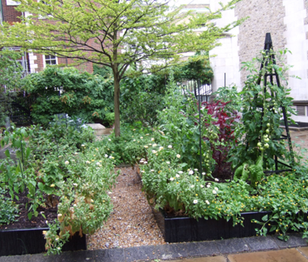
Winner of the Gardeners’ Company Flowers in the City Competition
for Best Enclosed Courtyard - Summer 2024

Gardeners’ Company
Chief Executive / Clerk

About the Gardeners’ Company
The Gardeners’ Company is a Livery Company – a membership organisation with a long history and close ties to the City of London. Today our growing membership of 300+ is made up of professional and amateur horticulturists from a wide range of backgrounds; all are united by a passion for horticulture, gardens and the natural world.
We were founded in mediaeval times – the first record of our organisation dates back to 1345 – by gardeners who practised their craft in the City of London. We were formally constituted with the grant of a Royal Charter in 1605.
Today, the Gardeners' Company runs a busy events programme comprising lectures, talks and presentations by eminent horticulturalists; outings to explore and learn about beautiful gardens and landscapes; and formal dinners and lunches at historic City of London venues.
Through offering warm hospitality and this wide range of shared activities, the Company builds relationships among its members, as well as with partners from the horticulture industry and across the City of London. The resulting bonds of friendship and trust are the vital foundations upon which we carry out the remainder of our work. This work takes three forms.
First, we run a select number of in-house projects, many of which focus on nurturing the next generation of horticulturists. Our Schools Outreach programme for example uses engaging presentations and outings to introduce school children – from diverse ages and backgrounds – to the myriad career opportunities available to them in horticulture. We also support those later in their career journeys, offering awards and scholarships to student and apprentice horticulturists.
Second, we work with partners to incubate new horticultural initiatives. Our members generate ideas, attract collaborators and provide start-up resources (whether financial or in-kind), with the intention of establishing new projects that can flourish independently. In recent years we’ve helped to set up: a horticultural training programme (Future Gardeners); the habitat-development and advocacy work of Pollinating London Together; and the Livery Climate Action Group.
(In parallel, the Company Charity – a separate entity, but one that is largely funded by donations from our members – awards close to £100k in grants to horticultural projects each year).
Third, and most ambitiously, we want to be a convenor and catalyst for change, bringing key players together to solve challenges that face the horticulture sector. With our unique position – spanning horticulture, the City, the charity sector, and a wide range of other disciplines – we are well-placed to play this role. Over the coming years, our efforts will increasingly focus on this important area of work.

Job Description
The Gardeners’ Company – formally known as the Worshipful Company of Gardeners – is a flourishing membership organisation with ambitious plans for the future.
We combine ancient roots with a 21st-century mission: celebrating and promoting contemporary horticulture, in all its rich and varied forms.
We are seeking an individual who, as Chief Executive / Clerk to the Company, will guide and support us through an ongoing period of growth and renewal.
We recognise that the necessary skills and qualities could have been acquired in many different contexts, and we are open to candidates from the widest possible range of backgrounds. Experience of Livery companies, the City of London and/or the horticulture sector may be helpful but is not required

Governance and strategy

As de facto Chief Executive of the Worshipful Company of Gardeners, serve as custodian of the Company’s heritage and traditions while nurturing and implementing its contemporary vision and strategy
- Act as Secretary to the Court of Assistants (Board of Directors equivalent)
- Support the chairs of the Company’s various committees, helping them to hold regular and effective meetings
- Provide advice, guidance and briefings to the office holders of the Company

Member recruitment and engagement
- Develop and implement strategies to recruit a wide range of new members, ensuring the Company can continue to grow and realise its ambitions
- Facilitate the process for membership applications and onboarding in conjunction with the Membership Secretary
- Develop and implement new schemes for corporate membership of the Company

Events
- Lead on organising the Company’s major City functions)
- Oversee the Events & Communications Officer and liaise with members to deliver a full, varied and accessible programme of other educational and social events for members
- Ensure suitable budgets are produced for all functions and events, and that income and expenditure are monitored effectively
- Fulfil all necessary ceremonial duties and functions, in conjunction with the Beadle and the Ceremonial Assistant

Finances
- Oversee the Finance Officer and work with the Treasurer and Finance Committee to ensure effective financial management and timely and accurate financial reporting
- Develop the annual organisational budget; monitor income and expenditure; ensure the timely collection of subscriptions and other payments from members
- Maintain and care for the Company’s physical assets (including gowns, badges, silverware and other treasures), in conjunction with the Beadle

Communications
- Maintain and develop the Company’s narrative
- Support the Communications Committee in developing and implementing the Company’s strategy for internal and external communications
- Oversee staff, contractors and volunteers who work on marketing and communications
- Oversee the maintenance and development of the Company’s website

HR and administration
- Manage staff and contractors
- Maintain a forward view of the Company’s activities
- Liaise with and oversee the work of service providers (e.g. investment managers, insurers, external accountants, legal and professional advisers, website and software providers)
- Liaise closely with representatives of the Worshipful Company of Gardeners of London Charity
- Maintain software and office systems, including the membership database

Representing the Company
- Act as first point-of-contact for and be an important part of the public face of the Company.
- Maintain and develop the Company’s relationships with other Livery companies, the Fellowship of Clerks and institutions of the civic City
- Maintain and develop strong personal and institutional links with partners from across the horticulture sector
- Manage the Master’s diary of Company commitments and ensure the Company is suitably represented at a range of City, Livery and horticultural events
- Act as an ambassador for the Company and attend a large number of internal and external functions and visits, both in the City of London and further afield

The successful candidate will need to remain flexible and adaptable to change in the role over time.

PERSON SPECIFICATION

This could be the ideal role if you wish to join an active, forward-looking Company. You will need to:
- Demonstrate strategic awareness with the ability to deliver agreed objectives
- Be flexible, able to work under pressure across multiple roles and adaptable to change
- Have confident and up-to-date IT and online skills and the ability to use and leverage social media
- Have excellent hands-on administrative and organisational abilities
- Have excellent verbal and written communication skills
- Demonstrate sound financial management
- Be comfortable managing formal ceremonial events and the protocols involved.
- Be friendly and approachable, with excellent people skills and an ability to inspire confidence
- Be a team player
- Become – or be already - well networked in the City of London
- Be based within easy reach of the City of London

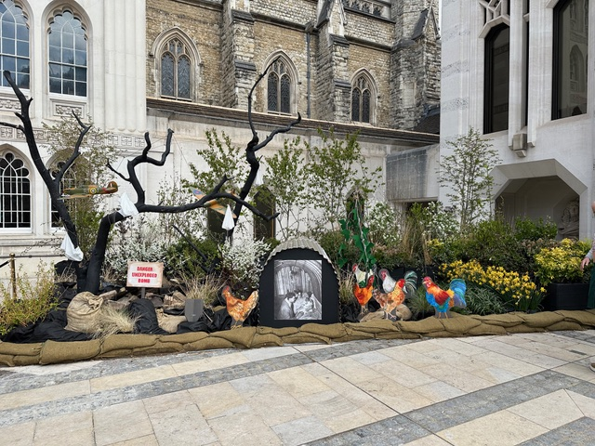
Gardeners’ Company Guildhall Garden in support of the Lord Mayor’s Big Curry Lunch 2025
Gianna Utilini Garden Designs Registered member of Society of Garden Designers.

EMPLOYMENT TERMS & CONDITIONS

Location: The Company does not have a Hall or offices in the City and holds meetings in the Halls of other City of London Livery companies or the Guildhall. The Chief Executive / Clerk works from home and will travel to meeting venues as required.

Reporting to: The Master
Salary: £55,000 p.a

Pension: A 5% employer’s scheme is offered

Work Days: 4 days per week. Flexibility is key. Within the City and Company calendars some months are far busier than others.
Holiday: 20 days of paid holiday plus bank holidays per annum. Dates must be arranged with the Master’s prior approval (The leave year runs from 1 July; holiday allowance prior to that date will be on a pro rata basis)
Probation Period: There will be a probation period of three months, after satisfactory
completion of which the position will become permanent with a
three-month notice period.

Start date: Early September 2025, or as soon as possible thereafter
Full details and terms and conditions of employment will be issued when an offer of employment is made.

HOW TO APPLY

Download further details of the position from our website:
www.maryleboneexecutivesearch.com/jobs
For an informal confidential discussion call Richard Evans on 07958 984161 or 020 3126 4858 or Kevin Everett on 07771 783265
Apply online with a full curriculum vitae detailing your skills and experience together with a maximum two-page Personal Statement clearly outlining your motivation to undertake the role and how you meet the competencies required for the position as stated in the Person Specification.

Application process
Closing date for applications: 14 July 2025
Long List interviews: 21 July – 1 August 2025
Final Panel Interviews: 14 August Held in-person in the City of London
To find out more about the Company visit: www.gardenerscompany.org.uk
The Company embraces all aspects of diversity and welcomes applications from all sections of the Community

